
NAME : VAANI JINDAL
SAP : 500119144
BATCH : 2
SUBJECT : OOPS

EXPERIMENT -2

- QUES : Write a program to find the area of a shape (Rectangle, Square, Circle, Triangle) using method overloading.
Code :

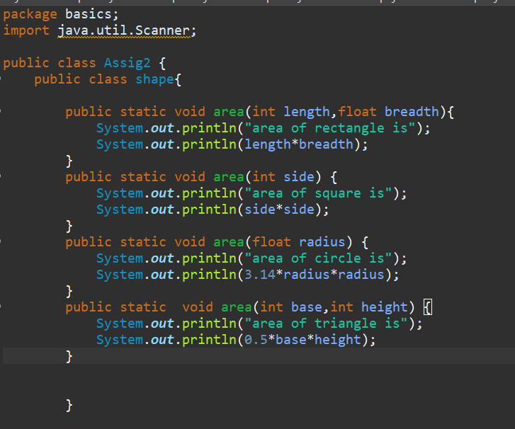

OUTPUT:
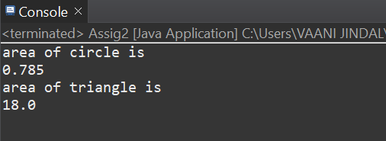
- QUES : Write a program to calculate the final grade of a student based on the marks entered in three subjects. Use the following grading scale:
Average >= 90: Grade A
Average >= 75: Grade B
Average >= 50: Grade C
Otherwise: Grade F

CODE :
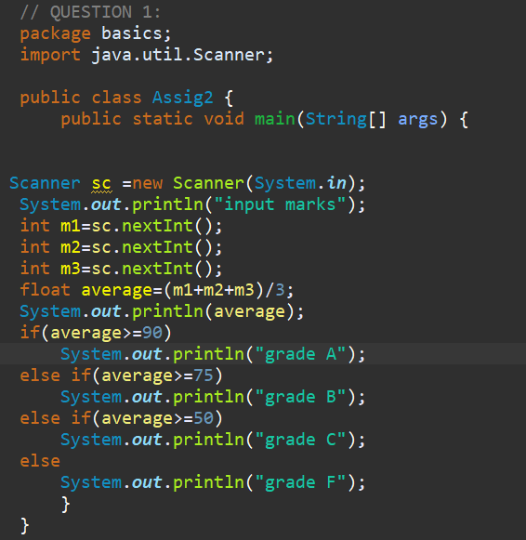
OUTPUT:
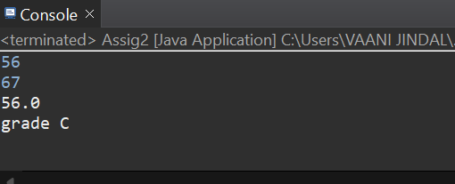
- ques : Create a program that accepts a number (1–7) and displays the corresponding day of the week using a switch statement.
Code :
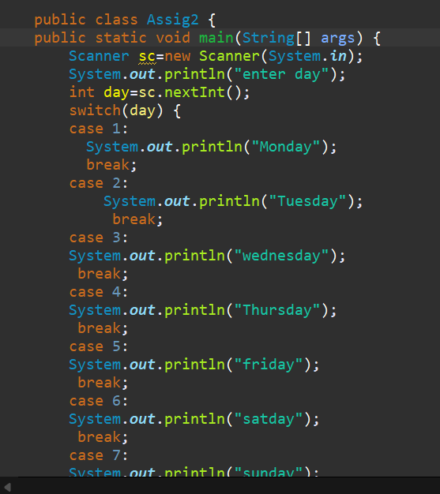
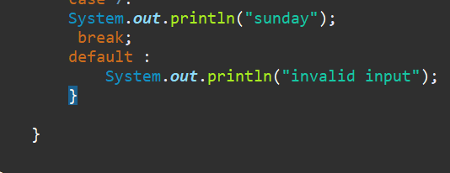
output: 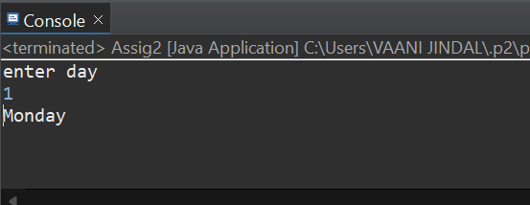
- Ques : Print this Pattern:
1 2 3 4 5
1 2 3 4
1 2 3
1 2
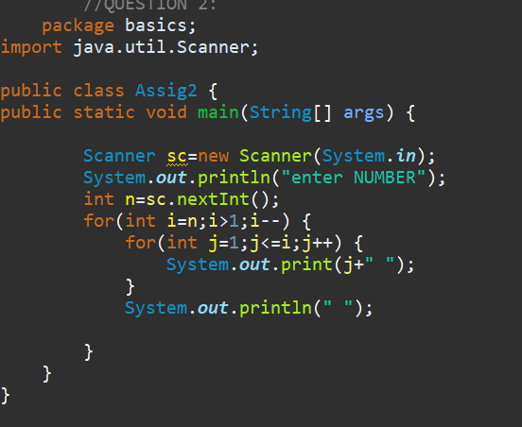
1
Code :

Output:
